5-2 Activity: Encryption Coding

Joel Meza

Professor Trevor Hodde

February 2, 2022

CS 405 – Secure Coding

Southern New Hampshire University

Overview Summary

According to the for() loop, the ideal functionality is to encrypt the string given where for each character from the string, it is done by XOR encryption that’s accounted for key lengths. Within the initialization of the for loop, the “size_t” is set to be equal to 0 (zero) to begin from there and start iterating by allocating each character. While its iterating within the XOR encryption, the next parameter in the for loop starts to iterate as well and counts between each character from the source string to know when to end the iterations. Although, once the for loop has been completed then we apply the assertion outside of the for loop to begin to test if the output string given is equal to the same amount in characters length as the source string provided. Below as shown is also a “string::read_file()” method which its ideal functionality is to read and deploy into a string called, “file_text”. Therefore, the text file is closed, and the new version of the string is sent back.

Below is an example of the compiled code:

Now, the new file has been stored which contains the parameters or arguments of a student name, key, data, and file name. Therefore, we store the given data into a file with the help of the “fileStream” method which generates all data into the new text file. Below is an example of the compiled code:

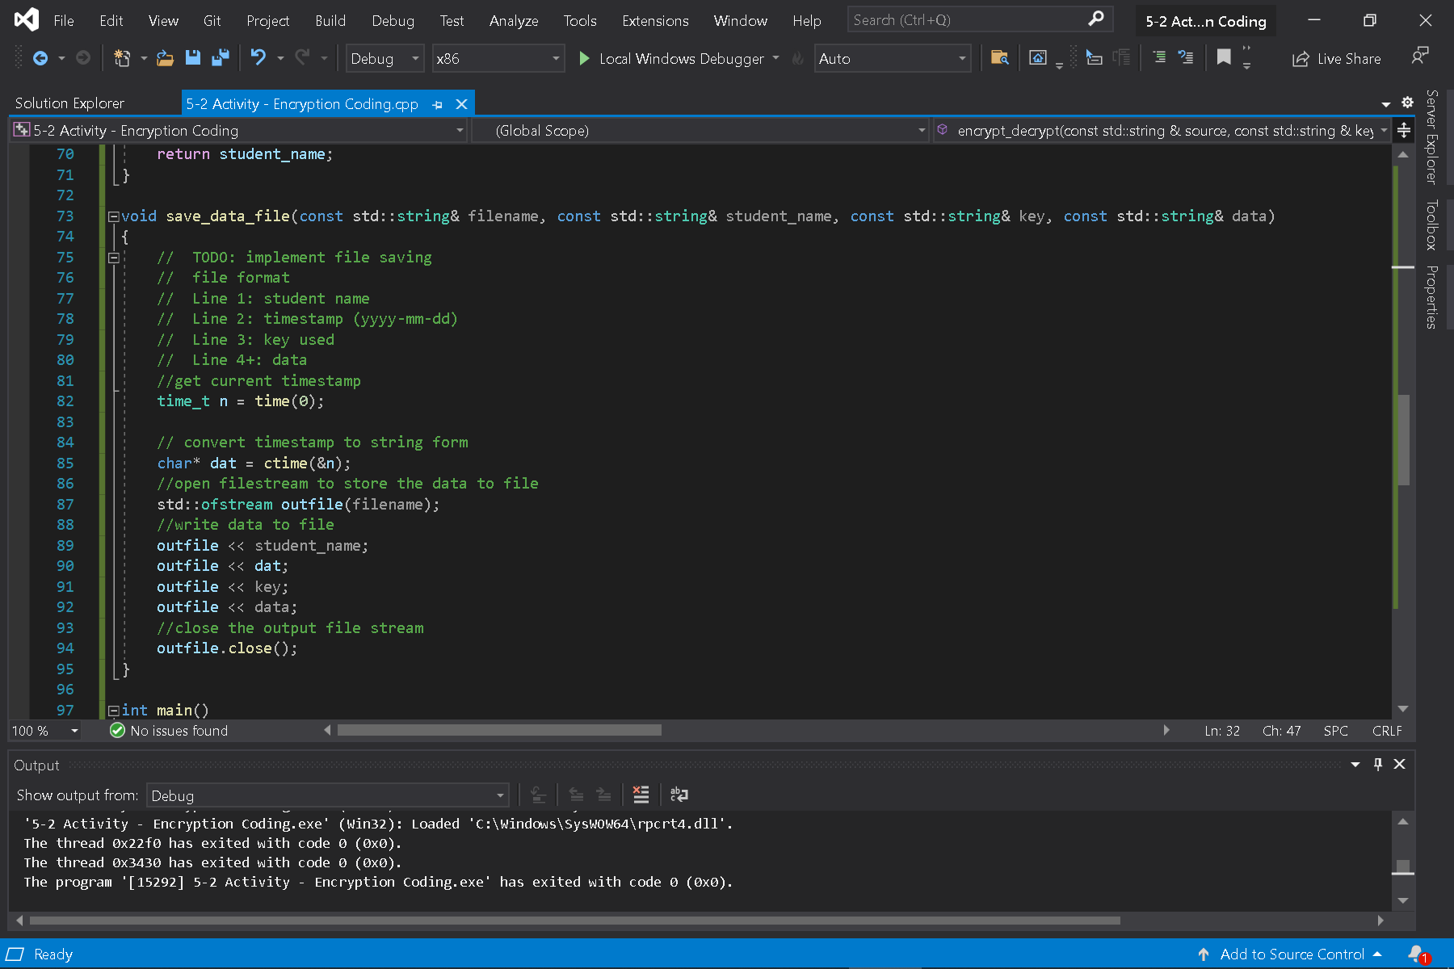

Lastly, we start to run the program which gives us a console output of the text file that was read, where and what file the encrypted data got stored into, and where and what file the decrypted data got stored into as shown below:

